**QUIZ ON**

**THE PHANTOM OF THE OPERA**

# Who does the Phantom like?

Carlotta Christine Meg



Mme Giry

# What does the Phantom wear that makes him look different?



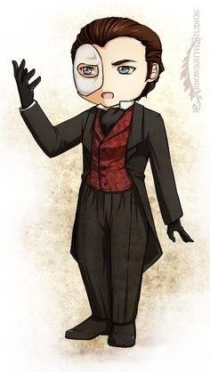A mask Gloves White shoes

A red clown nose

# Who is Christine's love?

M Andre Ubaldo Raoul



M Firmin

# Who is the best ballet dancer ?



La sorelli Madame Giry Christine Carlotta

# Who is scared off by the Phantom because he set a curse on her ?

Christine Carlotta Meg



Mme Giry

# What does the Phantom give Christine as a sign of love ?

A scarf A ring



A puppy

A necklace

# Which of the following characters die?

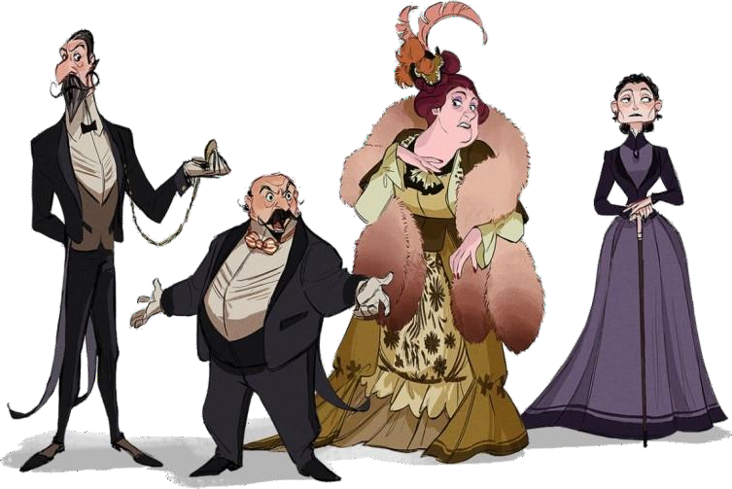Mme Giry Carlotta Buquet



The Phantom

1. What is Christine's last name?



Daae Tunque Piaget Bergmann

# Is Meg Giry the daughter of Monsieur Richard?

Yes No



# Who are the new managers of the opera house?

Raoul and Buquet Christine and the Phantom Meg and Madame Giry Andre and Firmin



# What does the main female character call The Phantom?

The Phantom Lefèvre Professor



Angel of Music

# What was the Phantom's background?

A child burned by acid on his face An architect from Persia



An escaped fair-ground freak

A runaway who couldn't find anywhere else to go

# What is the "room of mirrors"?

* + La Carlotta's dressing room



* + - a trap under the opera house
* a secret part of Christine's bedroom
* the Phantom's house

# Who gets caught in the room of mirrors?



* + Raoul & the Persian
* Christine & Raoul
* Carlotta & her pet dog
* Just Raoul

# What is the first thing that happens in the room of mirrors?

* It gets freezing cold.
* It gets burning hot.



* + 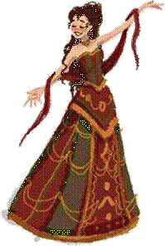It fills with water.
  + It fills with sand.

# Who is the "Opera Ghost"?

* a name used by the Phantom to sign letters



* + a pen-name used by the Phantom when he writes operas
  + a character played by La Carlotta in a show
* the name of a show

# What is a chandelier?

* 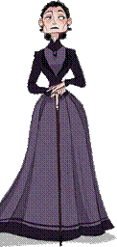a type of French cookie
* a type of dog that Carlotta likes



* + a special kind of hairstyle
    - a big light in the middle of the opera house

# What happens to the chandelier?

* + Raoul uses it to swing across the opera house.



* + - The Phantom makes it fall on the audience.
    - Christine cleans it each morning.
* The opera house owners don't like it so they buy a new one.

# What does the Phantom ask the owners to do?



* + Pay him 20,000 francs a month, keep Box 5 for him, and don't let Carlotta sing.
*  Pay him 20,000 francs a year, leave him alone, and don't let Christine sing.
*  Get rid of Raoul, pay him 50,000 francs a month, and keep Box 2 for him.
* Let him go on a dinner date with Carlotta.

# What is the name of the author of the book ? Gaston Leroux

**OPINION: Did you like the story ? Why ?**

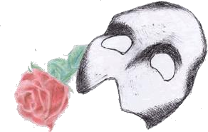**I liked because there are a lot of mysterious moments and you fell intrigued and you need to read more and fell good.**