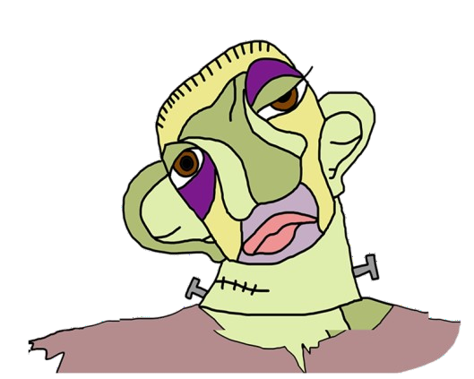MONSTERS

|  |  |  |  |
| --- | --- | --- | --- |
|  | **THE MONSTER**  **OF VICTOR FRANKENSTEIN** | **QUASIMODO** | **THE ELEPHANT MAN** |
| **REAL PERSON OR CHARACTER ?** | Character | Character | Real person |
| **WHO CREATED HIM?** | Mary Shelly | Victor Hugo | Biography written |
| **WHEN ?** | 1817 | 1831 | 1980 |
| **BOOK HE BELONGS TO** | Frankenstein | The hunch buck of Notre-dame | The true history of the elephant man |
| **HIS PROBLEM** | He is a monster made of bodies of different people | Quasimodo has been abandoned by her mother and he works at the cathedral | He was deformed |
| **COULD HE BE HAPPY?** | No because the people are scared off him and he feels alone | Yes because the people finally could accept him | At the beginning of the story yes because her mother makes him happy but she dies and he feels alone |
| **HOW DID HIS LIFE END?** | He finally kills himself | He kisses Esmeralda | He dies because of his deformations |